**ABSTRACT**

Student Management System is a software developed for daily student activity in schools, colleges and institutes. If facilitates to access the Student information of a particular student in a particular class. The information is sorted by the operators, which will be provided by the teacher for a particular class. This system will also help in evaluating Student eligibility criteria of a student. This document is meant for describing all the features and procedures that were followed while developing the system. This document specially mentions the details of the project how it was developed, the primary requirement, as well as various features and functionalities of the project and the procedures followed in achieving these objectives. This system helps in conducting Student quickly and can thus help in saving time and the operations will be carried out efficiently.

**Software Requirements**

|  |  |
| --- | --- |
| Name of component | Specification |
| Operating System | Windows, Linux |
| Language | Java SE / EE |
| Database | ORACLE Server |
| Browser | Any of Mozilla, Opera, Chrome etc |
| Web Server | Tomcat 9 |
| Software Development Kit | Java JDK 9.0 or Above |
| Scripting Language Enable | JSP & Java Script |
| Database JDBC Driver | Type- 4 / Thin driver |
| Architecture | MVC (Model View Controller) |
| IDE | Eclipse Photon |
| Editor | Sublime |

**Hardware Requirements**

|  |  |
| --- | --- |
| Name of component | Specification |
| Processor | Pentium Dual-Core CPU or Above |
| RAM | 2 GB Or more |
| Hard disc | 20 GB or more |
| Monitor | 15” color monitor or advance |
| Keyboard | Any Keyboard |
| Mouse | Any mouse |
| Printer | In case of printing reports |

**Drawback of Existing System**

In the present system all work is done on paper. System Analysis is a detailed study of the various operations performed by a system and their relationships within and outside of the system. Here the key question is- what all problems exist in the present system? What must be done to solve the problem? Analysis begins when a user or manager begins a study of the program using existing system.

During analysis, data collected on the various files, decision points and transactions handled by the present system. The commonly used tools in the system are Data Flow Diagram, interviews, etc. Training, experience and common sense are required for collection of relevant information needed to develop the system. The success of the system depends largely on how clearly the problem is defined, thoroughly investigated and properly carried out through the choice of solution.

In the current system we need to keep a number of records related to the student and want to enter the details of the student and the marks manually. In this system only the teacher or the school authority views the mark of the student and they want to enter the details of the student. This is time consuming and has much cost. Disadvantages of Present Working System:

* **Not User Friendly:** The existing system is not user friendly because the retrieval of data is very slow and data is not maintained efficiently.
* **Difficulty in report generating:** We require more calculations to generate the report so it is generated at the end of the session. And the student not get a single chance to improve their Student.
* **Manual control:** All calculations to generate report is done manually so there is greater chance of errors.
* **Lots of paperwork:** Existing system requires lot of paper work. Loss of even a single register/record led to difficult situation because all the papers are needed to generate the reports.
* **Time consuming:** Every work is done manually so we cannot generate report in the middle of the session or as per the requirement because it is very time consuming.

**Need for new System**

* User friendly interface
* Fast access to database
* Less error
* More Storage Capacity
* Search facility
* Look and Feel Environment
* Quick transaction
* To improve the existing system.
* To develop a scalable system.
* To be highly available
* More secure

**Implementation Methodology**

Model View Controller or MVC as it is popularly called, is a software design pattern for developing web applications. A Model View Controller pattern is made up of the following three parts: Model - The lowest level of the pattern which is responsible for maintaining data. View - This is responsible for displaying all or a portion of the data to the user. Controller - Software Code that controls the interactions between the Model and View.

MVC is popular as it isolates the application logic from the user interface layer and supports separation of concerns. Here the Controller receives all requests for the application and then works with the Model to prepare any data needed by the View. The View then uses the data prepared by the Controller to generate a final presentable response. The MVC abstraction can be graphically represented as follows.

**Model View Controller Diagram**

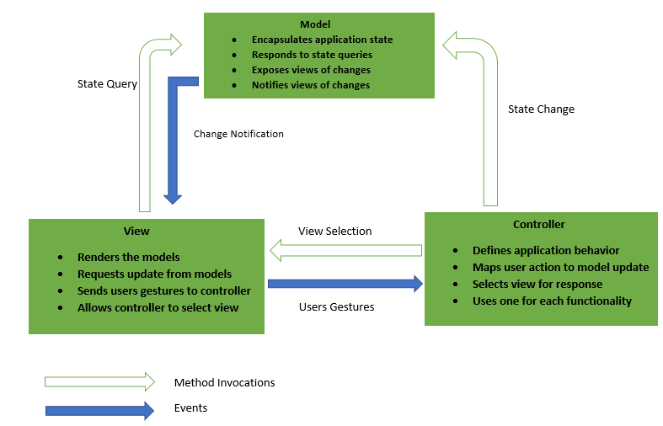

**OBJECTIVES**

The goal of designing input data is to make entry easy, logical and free from errors as possible. The entering data entry operators need to know the allocated space for each field; field sequence and which must match with that in the source document. The format in which the data fields are entered should be given in the input form. Here data entry is online; it makes use of processor that accepts commands and data from the operator through a key board. The input required is analysed by the processor. It is then accepted or rejected. Input stages include the following processes

* Data Recording
* Data Transcription
* Data Conversion
* Data Verification
* Data Control
* Data Transmission
* Data Correction

**OPERATIONAL DEFINATION**

There is a dire need of synchronization between the blood donors and hospitals and the blood banks. This improper management of blood leads to wastage of the available blood inventory. Improper communication and synchronization between the blood banks and hospitals leads to wastage of the blood available. These problems can be dealt with by automating the existing manual blood bank management system. A high-end, efficient, highly available and scalable system has to be developed to bridge the gap between the donors and the recipients and to reduce the efforts required to search for blood donors

*Teachers have the following facilities*

* Teacher can only able to login as they will get the id and password when they are registered by admin.
* Before login, if Teacher has forgotten his/her password then he/she can go for forgot password option.
* After successful login, Teacher can able to reset or change his password and also logout is account.
* There is multiple job that a teacher can perform:
* Teacher can able to view his profile.
* Can edit his profile
* Also, can update his photo
* A teacher can apply for leave, ad view his status whether the administration has approved his request or not.
* A teacher can give any no of feedback, and these details will be reflected to admin only.
* Teacher job is to take Student of students.
* On the basis of subject, semester and branch.
* After taking Student teacher will able to view the Student sheet and can able to the see the no of present or absent of that semester.
* Calculate each student Student percent.
* Check eligible for examination, if not eligible a message will be sent to that student i.e. not eligible to give exam due to shortage of Student percent.
* Teacher can see all the students of each semester and branch.
* View Result and Exam Schedule.
* A teacher can make a conversation with any students i.e. chatting.

*Students have the following facilities*

* Student can only able to login as they will get the id and password when they are registered by admin.
* Before login, if Student has forgotten his/her password then he/she can go for forgot password option.
* After successful login, Teacher can able to reset or change his password and also logout is account.
* There is multiple job that a teacher can perform:
* Student can able to view his profile.
* Can edit his profile
* Also, can update his photo
* A Student can apply for leave, ad view his status whether the administration has approved his request or not.
* A Student can give any no of feedback against any teacher or administration, and these details will be reflected to admin only.
* Student can view his/her Student list according to Date and Subject.
* Student can see all the teachers of that institution.
* View Result and Exam Schedule.
* A Student can make a conversation with any Teachers i.e. chatting.

*Admin have the following operational powers*

* Admin can only able to login from the id and password.
* Before login, if he/she has forgotten his/her password then he can go for forgot password option.
* After successful login, Admin can able to reset or change his password and also logout is account.
* There is multiple job that an admin can perform.
* View all the students.
* View all teachers.
* Delete any student.
* Delete any teacher
* View feedbacks from users.
* View Guest message.
* Help message.
* View Notification of newly added student/teacher.
* Maintain/view student details.
* He has the right to add student, teacher, subject. Subject will be added on the basis of branch and semester.
* Also, he has the right to delete student, teacher, subject.
* When a Student or a Teacher apply for Leave Application, Admin will give permission whether that student or teacher’s application will be approved or not.
* When a Student or a Teacher gives some feedback against a student, teacher or administrator, Admin will view all the details whether a student given or a teacher given. Admin will take the step to overcome these problems.
* Admin can also view all the students according to semester and branch as well as can view all teachers. Admin can

**Data Flow Diagram**

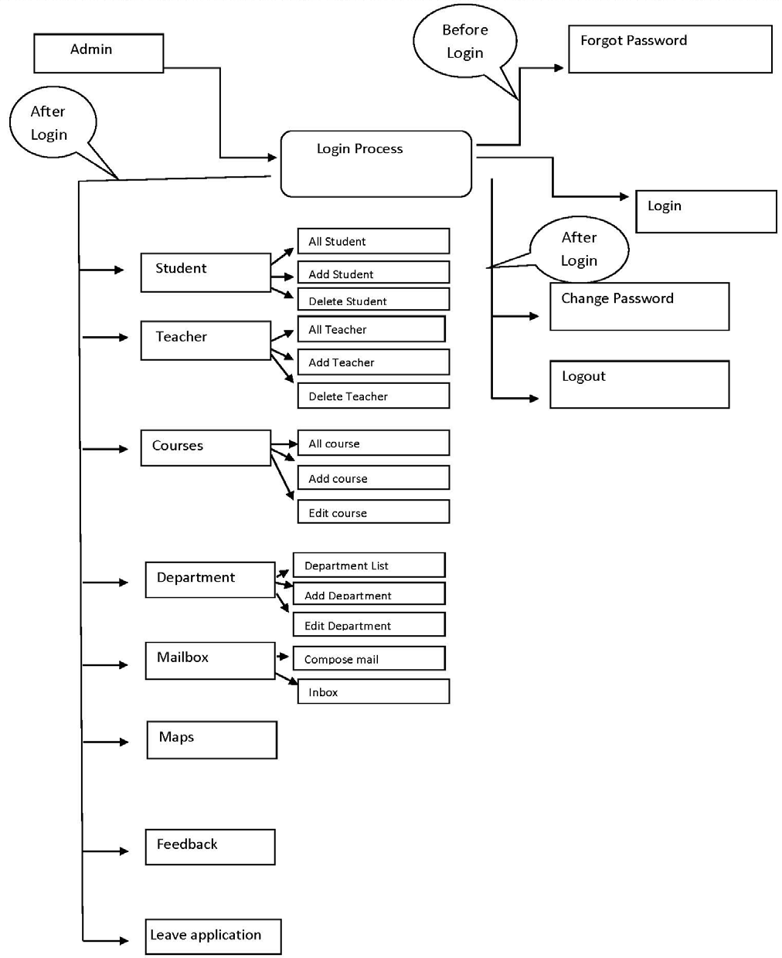

**Conclusion**

The Student Management System is developed by using Servlet, JSP and JDBC i.e. J2EE. It fully meets the objectives of the system which it has been developed. The system has reached a steady state where all bugs have been eliminated. The system is operated at a high level of efficiency and all the teachers and user associated with the system understands its advantage. The system solves the problem. It was intended to solve as requirement specification.

**Future Scope of the Project**

We have left all the options open so that if there is any other future requirement in the system by the user for the enhancement of the system then it is possible to implement them. The project has a very vast scope in future. The project can be implemented on intranet in future. Project can be update in near future as and requirement for the same arises, as it is very flexible in terms of expansion.